Algebra 1: Unit 13, Lesson H1

- The functions $f(x)$ and $g(x)$are shown on the graph.
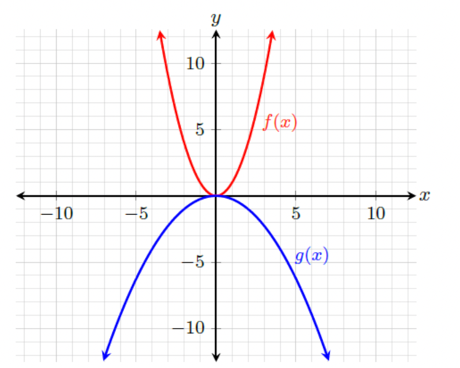

The function $g(x)$is represented by the transformation $kf\left(x\right)$. What is the $k$ value?
$$-\frac{1}{4}$$

- The table of values for functions $r(x)$ and $s(x)$ are shown.
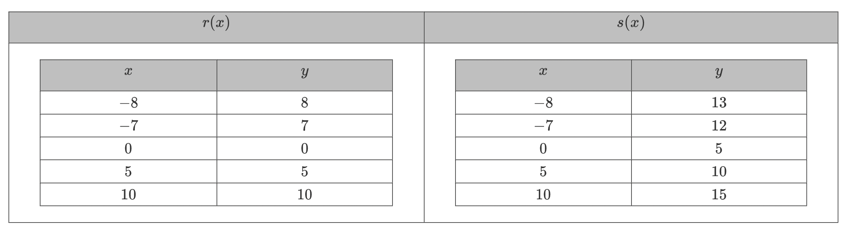
Complete the statement.
The function $s(x)$ is represented by the transformation $r\left(x\right)+k.$ What is the $k$ value?
$$5$$

- The graph of function $f(x)$ is shown on the coordinate grid.
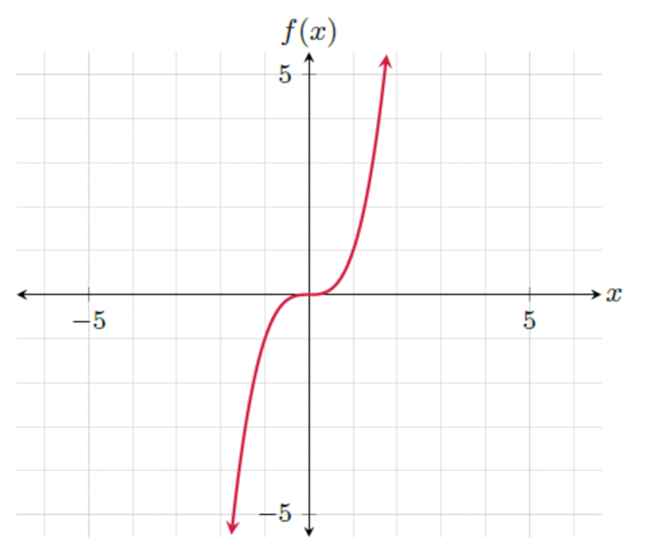

What transformation would occur to the graph $f(x-2)$?
Right 2 units

